**INFORMATION**

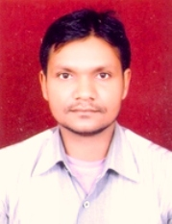**NAME:- Dashrath Verma**

**PASSPORT SIZE PIC:**

**Highest Qualification:- 3-Year Engineering Diploma in IT.**

**Designation:-Senior Technical Assistant**

**LAB No. Assigned:-CP-21(CS22)**

**Email Id:-dashratha.verma@gmail.com**

**Experience:-8years+**